Tugas Week 3 IS 429 Big data **Christopher Darren – 00000054804**

**“Google Data Studio”**

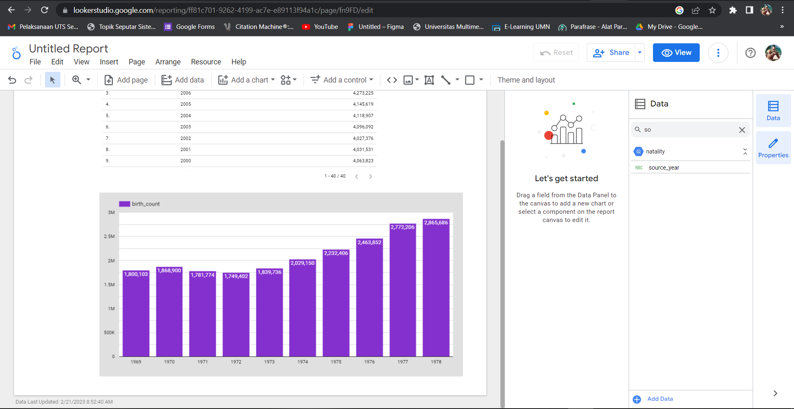

**Gambar 1. Birth count by year**

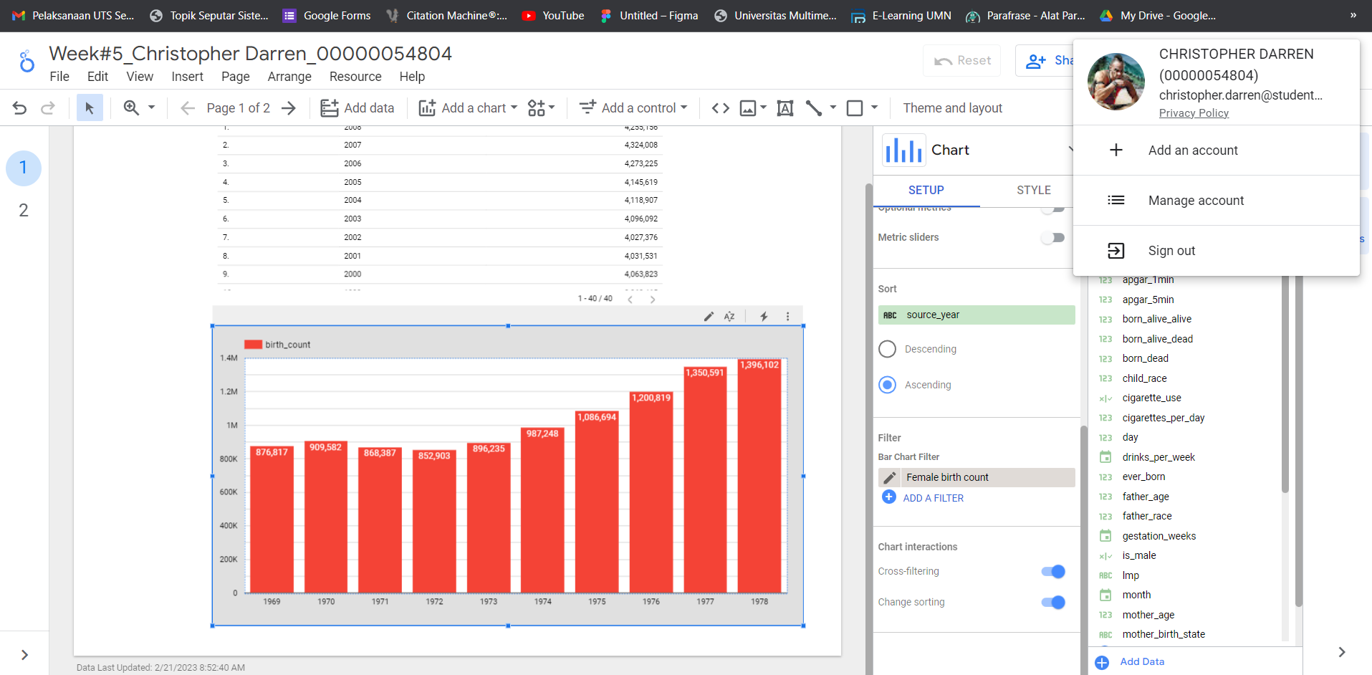

**Gambar 2. Female birth count year**

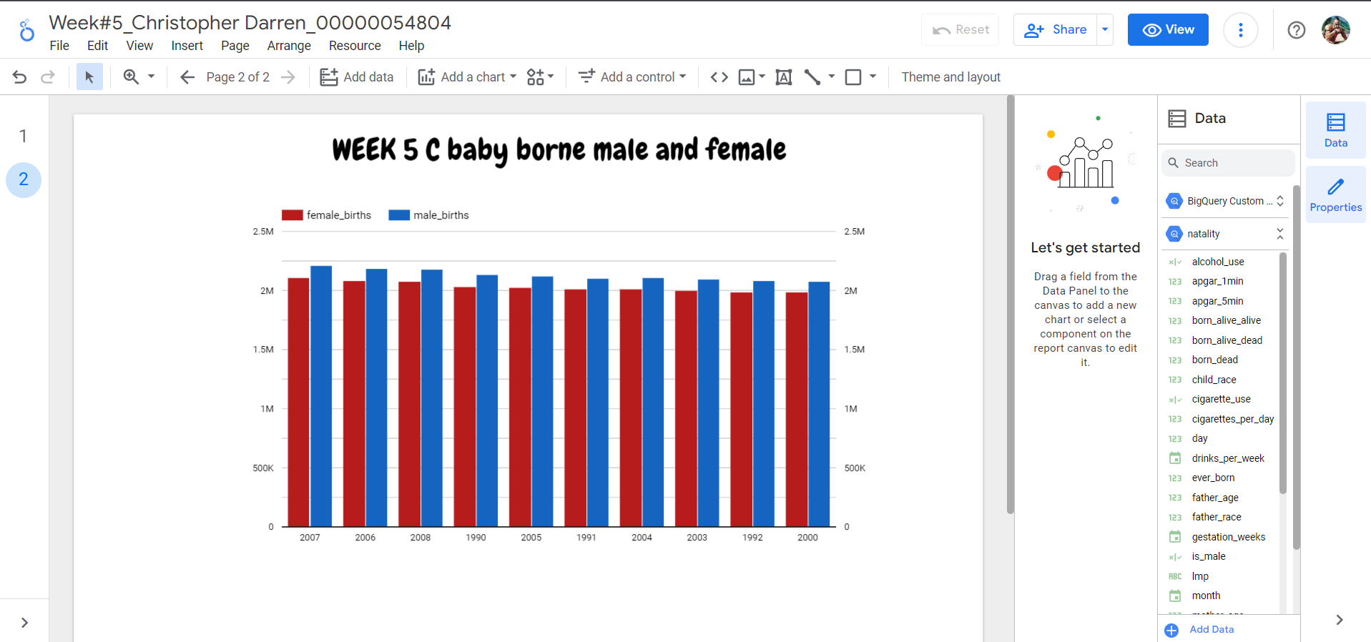

**Gambar 3. Baby borne male and female**

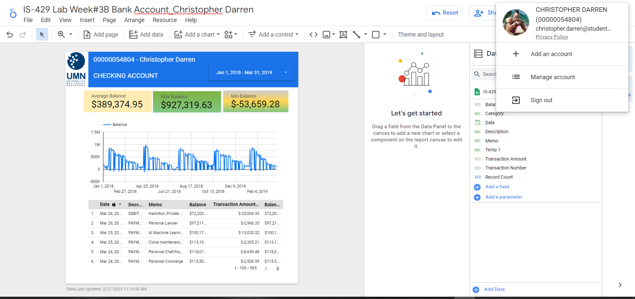

**Gambar 4. Visualization bank account**

**Link akses:**[**https://lookerstudio.google.com/reporting/ff81c701-9262-4199-ac7e-e89113f94a1c**](https://lookerstudio.google.com/reporting/ff81c701-9262-4199-ac7e-e89113f94a1c)